Why is Java platform independent?
When you write a Java program, the compiler converts your source code into an intermediate format called Bytecode (stored in .class files). This bytecode is universal and not tied to any specific OS or process
An operating system (OS) is essential system software that manages a computer's hardware, memory, and processes, while also acting as an interface between the user and the machine

Feature | ArrayList | LinkedList
Internal Structure | Dynamic (resizable) array | Doubly linked list (nodes with pointers)
Random Access | Fast: | Slow:
Insertion/Deletion | Slow:  (requires shifting elements) | Fast:  (only updates pointers)
Memory Usage | Low overhead (contiguous storage) | High (stores data + 2 pointers per node)
Iteration Speed | Fast (cache-friendly) | Slow (pointer chasing across memo
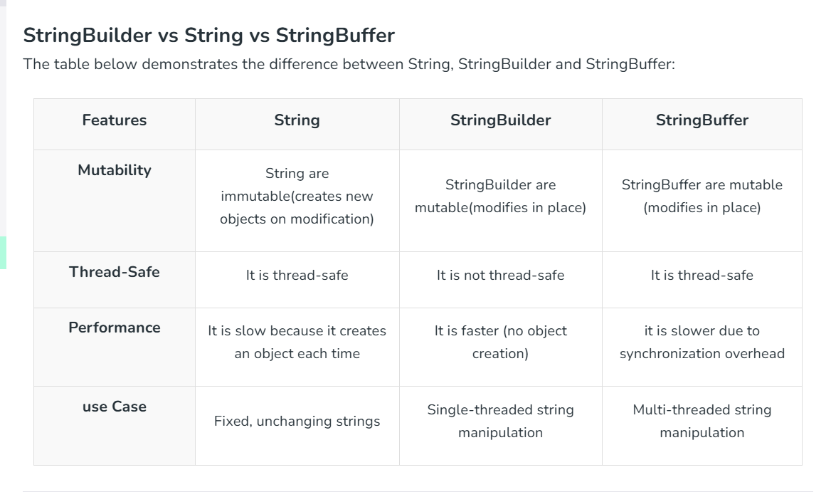
- length(): Returns the number of characters.
- charAt(int index): Returns the character at a specific index.
- substring(int begin, int end): Extracts a portion of the string.
- concat(String str): Appends a string to the end (returns a new string).
- toLowerCase() / toUpperCase(): Converts the case.
STRINGBUILDER
- append(): Adds data (of any type) to the end of the current sequence.
- insert(int offset, data): Inserts data at a specified position.
- replace(int start, int end, String str): Replaces characters in a given range.
- delete(int start, int end): Removes characters between specified indices.
- reverse(): Reverses the entire character sequence
- ✅ Types of Operating System (Simple)
- i. Batch Processing OS
- 👉 Runs many jobs together automatically
👉 No user interaction
- 🧠 Simple: Do tasks in groups (batch)

- ii. Multiprogramming OS
- 👉 Keeps many programs in memory
👉 Switches between them to use CPU better
- 🧠 Simple: CPU never stays idle

- iii. Multitasking OS
- 👉 One user runs many programs at same time
- 🧠 Simple: You can use browser + music + apps together

- iv. Real-Time OS (RTOS)
- 👉 Gives very fast response (no delay)
- 🧠 Simple: Instant result needed
👉 Example: satellites, medical systems

- v. Distributed OS
- 👉 Many computers work like one system
- 🧠 Simple: Multiple computers = one system
🔹 Interview Questions & Answers
❓ What technology did you use to send emails?
Answer:
I used EmailJS, which allows sending emails directly from the frontend without a backend server.

❓ Why use EmailJS instead of backend?
Answer:
- No need to build server APIs
- Faster development
- Easy integration

❓ Is this secure?
Answer:
Partially.
- Public keys are exposed in frontend
- For sensitive apps, backend is safer

❓ What are limitations?
Answer:
- Limited free quota
- Depends on third-party service
- Not ideal for high-security systems

❓ What is service ID and template ID?
Answer:
- Service ID → Email provider (Gmail, etc.)
- Template ID → Predefined email format

